**EXPERIMENT 10**

**Title:** Designing 3D objects using blender.

**Objective:** To design a three-dimensional model of a building using blender.

**Theory:**

Blender is the free and open source 3D creation suite. It supports the entirety of the 3D pipeline—modelling, rigging, animation, simulation, rendering, compositing and motion tracking, video editing and 2D animation pipeline. The latest version can be found on www.blender.org

**Procedure:**

**Step 1:** Open Blender. Create a blank file.

**Step 2:** Add a plane and scale it to an average area of a building using Shift+A>S.

**Step 3:** Switch to edit mode using TAB.

**Step 4:** Add some loop cuts using Ctrl+R, to create a division of rooms inside the hut. Loop cuts are needed to be added with respect to X and Y axis.

**Step 5:** Now, delete any one face on any level to bring the plane in L shape and extrude (E) it with respect to the z-axis such that it is equal to the six floors.

**Step 6:** To make a dome on the roof, extrude from corner from one of the ends of the building block. Add a similar plane in between both floors to differentiate between them.

**Step 7:** Next, add some pillars to the building by adding a plane first and then by scaling it with respect to z-axis. Now add the same pillar to every corner by just duplicating it. (Shift+D)

**Step 8:** To create the windows, add a frame apart from the frame for the building. Extrude the window according to how much depth you want. Now duplicate it using (Shift+D). Now, add an array modifier (x-axis) and increase the number according to the length of the roof. Add a second array modifier (y-axis) and increase the number according to the breadth of roof.

**Step 9:** Add the stairs to building by using add-on and then, use any of the textures to provide a brick layout for the building.

**Step 10:** Now, add a camera and a light source to it. And arrange the camera to the best fit view.

**Screenshots:**

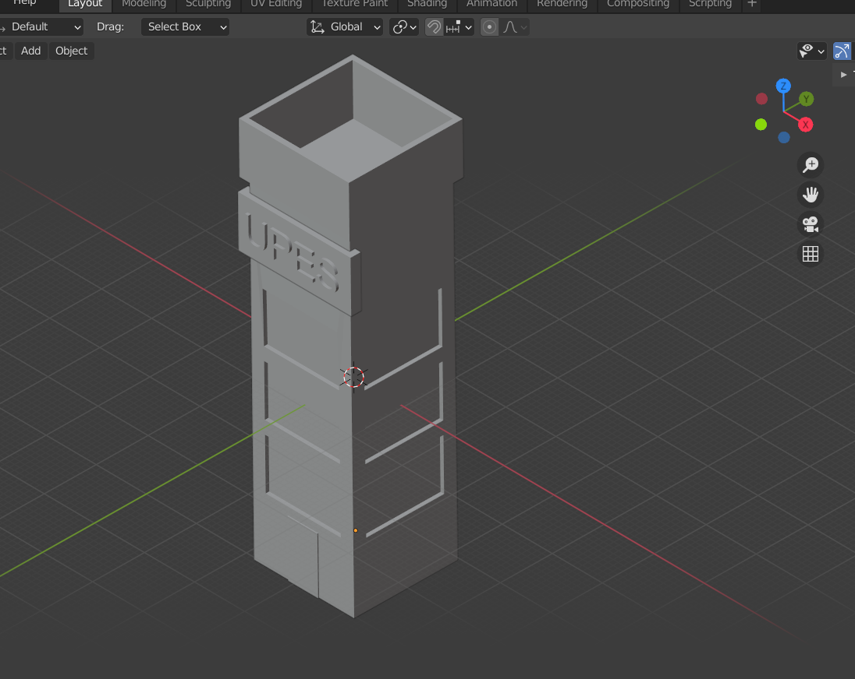

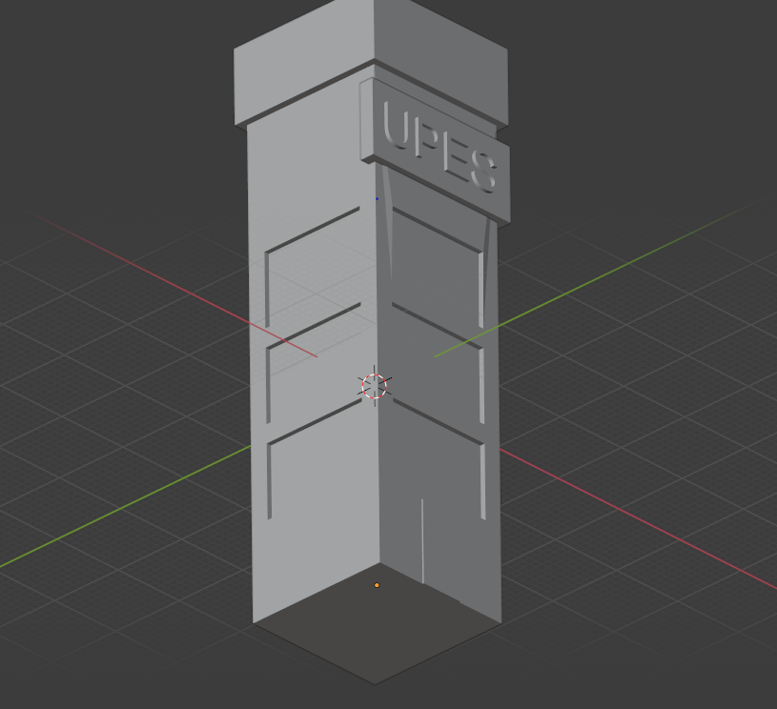

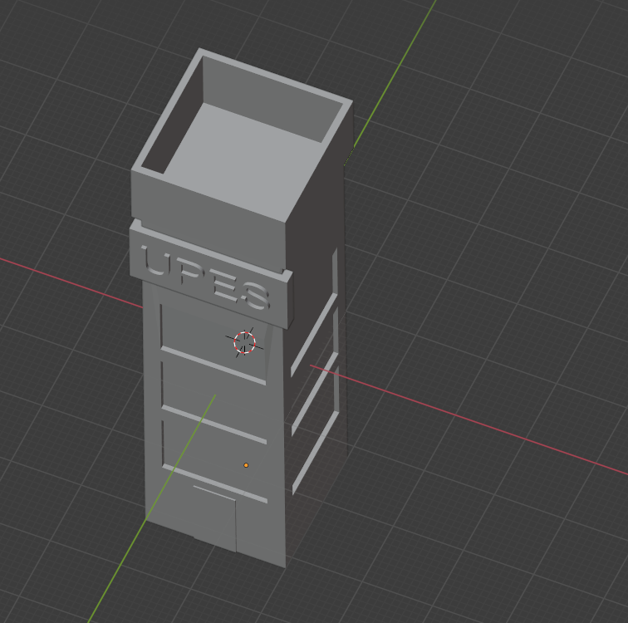

**Link:** [GAT Lab - Experiment 10 (All Files)](https://drive.google.com/drive/folders/1qdUPiAlLQggWeMzv5xhfDhu-eAxaw-Cg?usp=sharing)

**Conclusion:** Hence, we have designed a 3D model of building with a label UPES.